Api to get the user name and its picture in the home page 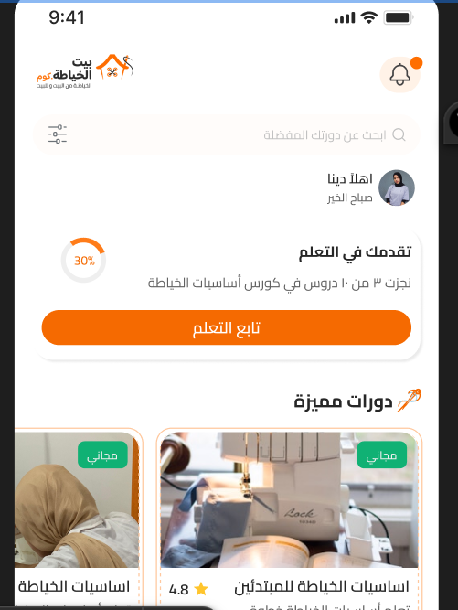

2- the progress should get the last course progress based on how much sessions of the totals sessions is completed and also the text you have completed 3 of 10 sessions for example
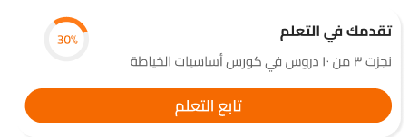
3-the دورات مميزة section should get only the courses that is Free Only
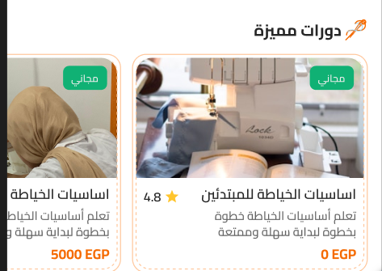
4-the api should return the product category picture (Level) and the level name and its price and also the rating of each category and also if its free or not also the description of each category or level
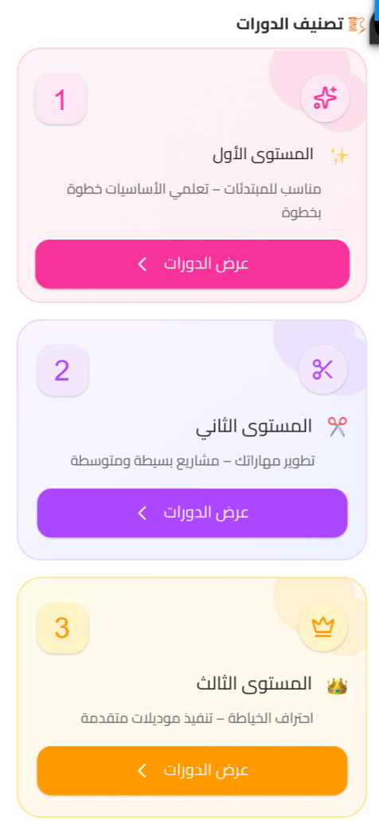
5-in the the community the level of every user should have a level and every level have ico also (Hold)
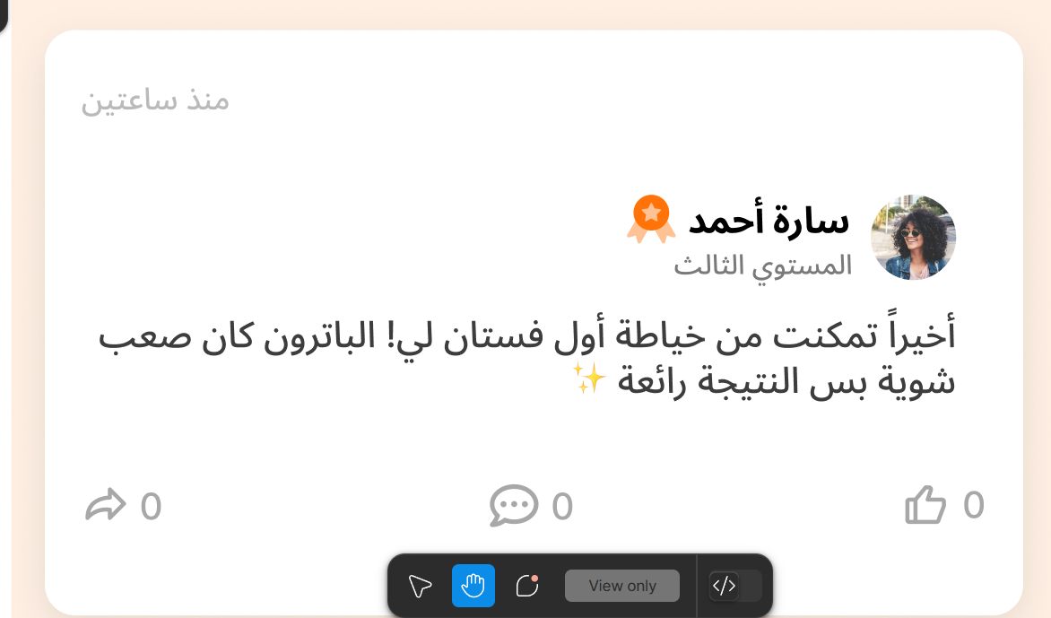

6-In the available Filtering option we need to add in the filtring of the courses
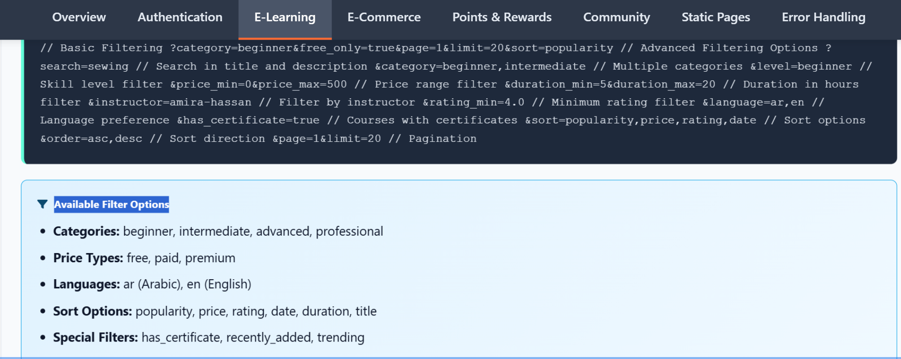

7-in every course should have description and the title of the course and how much sessions and how much hours and its level also and the teacher itself and its qualifications and its image of the teacher separated api
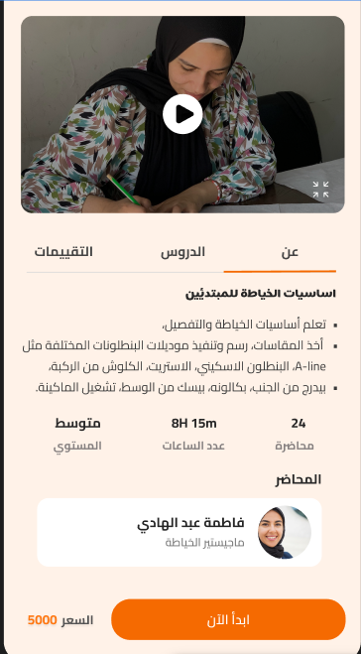
8-the lessons tab should also be separated tab and get all the lectures (Total) and its level
And its availability if its free to let the user view it or if its paid sessions so the user have to pay first before getting the course content and also every session and it estimated time this api should be separated
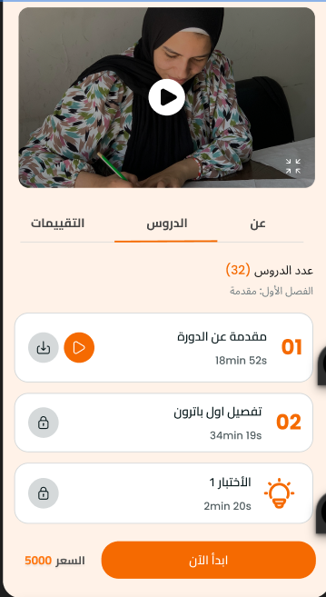

9-the Frequently Asked Questions of each course should be also avalibe in the
التقيمات tab okay but the name of the tab will be changed to FAQ also in separated api
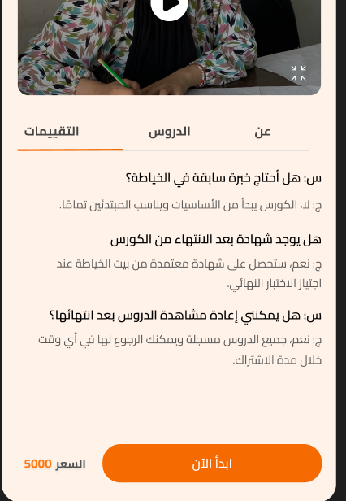
10-the price and start now button will redirect immediately to the Cart for the user to complete his payment to get access to the restricted content and the introduction video should be in all courses and static but it will get offcourse the price only that will be dynamic and also the Save button or (Wishlist Button ) should save the users wishing list and here the screenshots of the points of this separated api
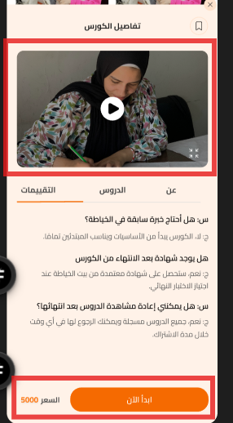
11-in the cart the products with type services shouldn’t have the quantity bar and also add the promo codes option and the price and price after discounts if they apply a promo code
And its Total Amount to pay and the button continue to the payment or complete the purchase page
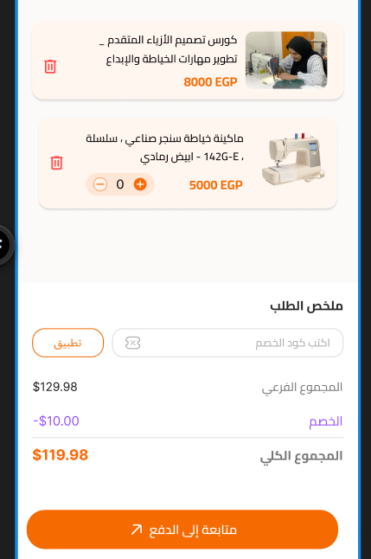
12- we need to add in the documentation to get all the course content and and its sessions (lessons) to recall it Any time
